Technical Architecture
Frontend – react.js, TailwindCSS
Backend – Expres.js
Integrations – speech-to-text API, Gemini/ChatGPT LLM API, google/ authentication
Database – MongoDB

User Flow –
- Landing Page
- Signup / Login
- Language Selection
- Initial Placement Test
- Dashboard (Progress Overview)
- Chat Screen
  - Text mode
  - Voice mode
  - Feedback / corrections
- Test Area
  - Reading test
  - Speaking test
  - Writing test
- Achievements / Level Updates
- Settings / Profile
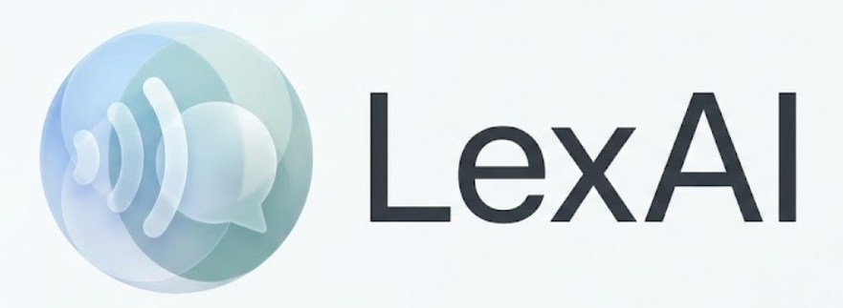
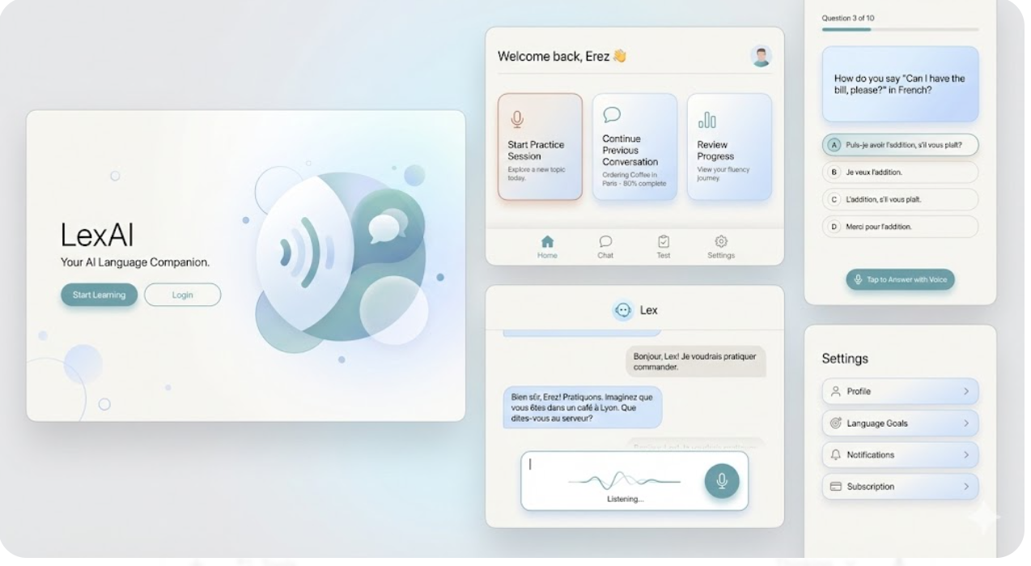
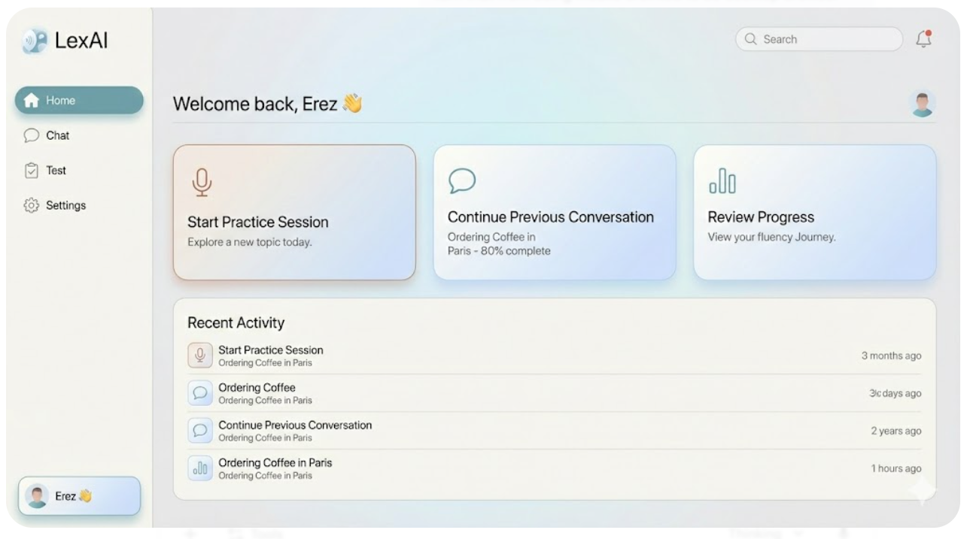
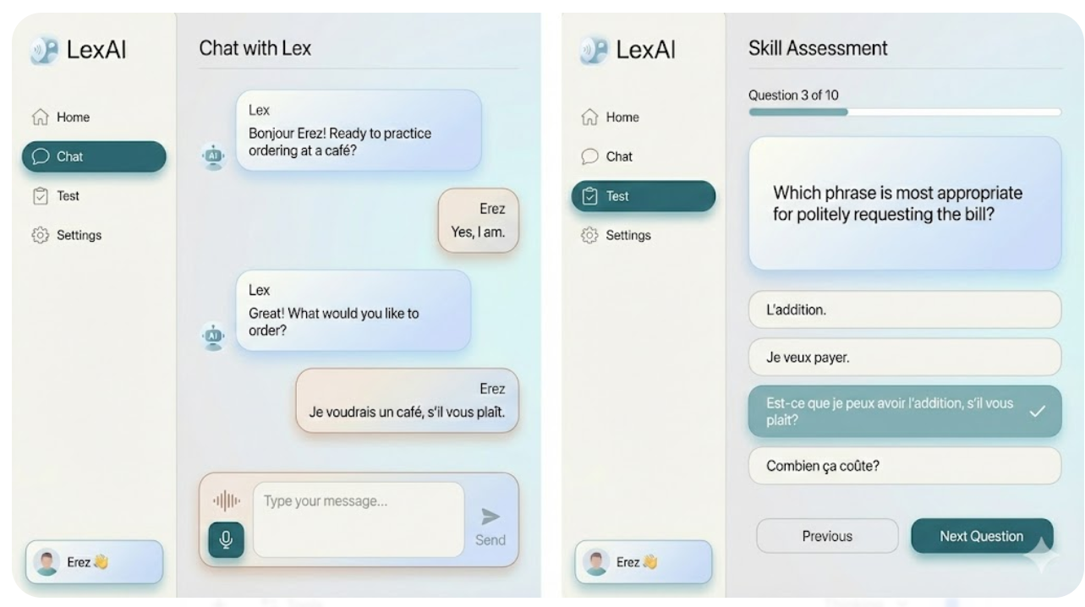
UI Concept A — “Sleek Fluent Minimalism”
Style Summary
A clean, premium, calm interface—similar to Notion, Headspace, and Grammarly Visual Style.
Perfect if you want LexAI to feel:
- Professional
- Trustworthy
- High-end
- Focused
Design Elements
- Color Palette: Soft neutrals
  - Whites, light gray, warm beige, soft blue accents
- Typography: Sans-serif premium type
  - Inter / SF Pro / Poppins
- UI Shape Language:
  - Rounded cards
  - Plenty of whitespace
  - Floating panels
- Animations: Very subtle micro-interactions
Screens Feel Like:
- Home Dashboard = Clean stat cards, progress bar, no clutter
- Chat Screen = iMessage meets Duolingo, large message bubbles
- Tests UI = Minimal cards with one question at a time
- Voice Mode = Circular waveform animation
Who is it for?
Users who want something:
- Serious
- Productivity-oriented
- “Grown-up”
- Feels like a true AI tutor, not a game
Why this works?
Because LexAI positions itself as smart & helpful, not gamified.

Here is your blueprint for building this in React.js (ideally using Tailwind CSS, as it handles this specific design language best).

1. The Design System (The "DNA")
Before you write component logic, you need to define your variables. This specific look relies on Inter (font) and a Slate/Stone (color) palette.
Typography
- Font Family: Inter (Google Fonts). It is the closest free equivalent to Apple’s SF Pro.
- Why: It has tall x-heights (readable at small sizes) and neutral geometry.
- Usage:
  - Headings: Inter, Weight 600 (SemiBold), Tracking -0.025em (Tight).
  - Body: Inter, Weight 400 (Regular).
  - UI Labels/Buttons: Inter, Weight 500 (Medium).
Color Palette (The "Notion-esque" Look)
We are avoiding pure black (#000000) and pure gray. We want "tinted" neutrals to make it feel premium.
Token | Hex Code | Tailwind Equivalent | Usage
Canvas | #F9FAFB | bg-gray-50 | The main page background (behind the cards).
Surface | #FFFFFF | bg-white | Chat bubbles, sidebar, input card.
Stroke | #E5E7EB | border-gray-200 | Thin borders on cards and inputs.
Text Primary | #111827 | text-gray-900 | Main content, user inputs, headers.
Text Secondary | #6B7280 | text-gray-500 | Timestamps, placeholder text, icons.
Accent (Soft) | #F3F4F6 | bg-gray-100 | AI Chat bubble background (neutral).
Accent (Active) | #3B82F6 | text-blue-500 | Very sparingly used for "Send" button or active icons.
Shadow | 0 4px 6px -1px rgba(0, 0, 0, 0.05) | shadow-sm | Soft, diffuse shadows on floating elements.

2. Detailed Component Styling
Here is how to style each specific piece to match the generated wireframes.
A. The Main Layout (Desktop Browser)
- Structure: A fixed Sidebar on the left, Main Content on the right.
- Background: Set the entire body background to Canvas (#F9FAFB).
- Radius: This design relies on "Super Ellipse" curves. Use border-radius: 24px (Tailwind rounded-3xl) for main containers if they are floating, or rounded-xl for inner elements.
B. The Sidebar
- Style: Minimal and flat. No heavy background colors.
- Active State: When a user is on the "Chat" tab, do not turn the button blue. Instead, give it a soft gray background (#F3F4F6) and darken the text.
- Icons: Use Heroicons (Outline) or Lucide React. These libraries use thin strokes (1.5px) which match the "Apple" aesthetic perfectly.
C. The Chat Interface
This is the core. It needs to look breathable.
- The Container:
  - Max-width: 800px (don't let lines stretch across the whole monitor).
  - Centered in the main view.
- AI Bubbles:
  - Background: #F3F4F6 (Gray 100) or #EFF6FF (Blue 50 - very subtle).
  - Text: #1F2937 (Gray 800).
  - Radius: rounded-2xl on the top-left, top-right, bottom-right. rounded-sm on the bottom-left (to show flow).
- User Bubbles:
  - Background: #FFFFFF (White).
  - Border: 1px solid #E5E7EB.
  - Shadow: shadow-sm (very subtle lift).
  - Text: #111827.
D. The "Floating" Input Area
This is the signature visual element of this concept.
- Design: Instead of a bar stuck to the bottom of the screen, it should be a floating card hovering about 40px from the bottom.
- Style:
  - Background: #FFFFFF.
  - Border: 1px solid #E5E7EB.
  - Shadow: box-shadow: 0 10px 15px -3px rgba(0, 0, 0, 0.05); (Soft elevation).
  - Radius: rounded-2xl (Very round).
- The Mic Button:
  - Don't make it red/bright. Make it a Circle.
  - Background: #F3F4F6 (Hover: #E5E7EB).
  - Icon: Dark Gray (#374151).
4. What makes it fail vs. succeed?
- FAIL: If you use default HTML shadows (too dark/sharp).
- SUCCESS: Use custom, high-diffusion shadows (low opacity, large blur).
- FAIL: If borders are too thick (2px or more).
- SUCCESS: Borders must be 1px and strictly #E5E7EB.
- FAIL: If everything is white.
- SUCCESS: You must have the subtle contrast between the #F9FAFB background and the #FFFFFF cards. That contrast defines the "Modern" look.

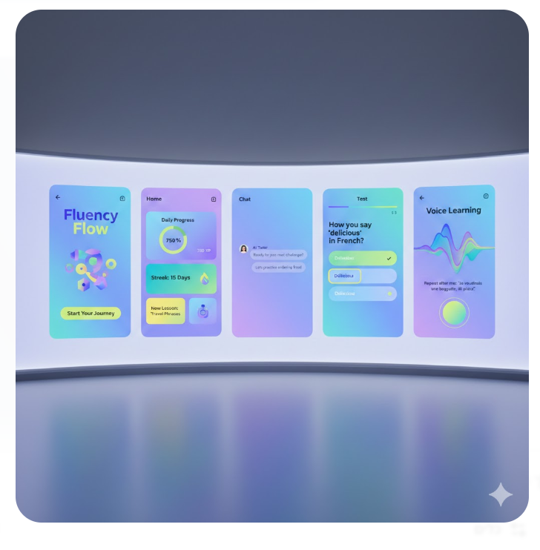
🎨 UI Concept B — “Friendly Neo-Modern”
Style Summary
Still mature, but more expressive and welcoming with soft gradients, colorful accents, and strong personality.
Not childish, more like:
- Duolingo without cartoons
- Spotify / Reddit aesthetics
- Calm bright gradients + solid UI
Design Elements
- Color Palette:
  - Blues, purples, teals
  - Light gradients
  - Vibrant accents (yellow/green)
- Typography:
  - SF Pro / Circular / Quicksand
- UI Shape Language:
  - Softer rounded rectangles
  - More color blocks
- Illustrations:
  - Abstract shapes
  - Not mascots
  - Clean geometric icons
Screens Feel Like:
- Dashboard = Color blocks showing progress, steps, streaks
- Chat Screen = Modern messenger style with colored backgrounds
- Test UI = Colorful but clean choices, progress indicators
- Voice Learning Screen = Big, expressive waveform
Who is it for?
Users who want:
- A modern, energetic experience
- Not too serious
- But not for kids
Why this works?
Creates motivation and energy without gamification silliness.
Mix of them:
